August

Homework Menu
You must complete at least one assignment a night. Homework checks will take place Tuesday – Friday Mornings.
At least 20 points are required weekly unless otherwise stated.
Ten Points | Five Points | Two points
Create a Toontastic OR SLIDES story using this week’s vocabulary words  1.  2.  3.  4.  L.4.6, W.4.3, SL.4.5  5.  L.4.5.c  6. | Create a word cloud using this week’s Vocabulary words and their synonyms. You may do this on paper or on abcya.com word cloud maker | Write each of this week’s vocabulary words in a sentence.  L.4.2, L.4.4.a
Choose and read two books on EPIC (or from the library) that have similar characters, themes, or topics.  Create a tree map identifying: similarities, differences, and new knowledge gained.  Book titles  RF.4.4  RL.4.9 or RI.4.6 | Read a book/portion of a book on EPIC or your own. Write four higher level thinking questions | Read a book/portion of a book that will help you reach your weekly reading goal. DO a reading log entry.  RF.4.4
Write a humorous “catchy tune” or song about place value and how to write  Multi-digit numbers in expanded form. The song should have at least four verses and a chorus.  4.NBT.A.2  4.NBT.A.2 | Research a famous person (athlete, actor/actress, singer, politician, etc.). Generate a list of at least five important numbers associated with them. Find the sum of those numbers and write it in: word form, standard form, and expanded form. | Create at least 10 multiplication and division fact families.  10x2=20  2x10=20  20÷10=2  4.NBT.B.5  20÷2=10
While reading a book of your choice find at least ten different words that follow the spelling rule for the week.  4.NBT.A, 4.NBT.B  L.4.2, RF.4.3 | 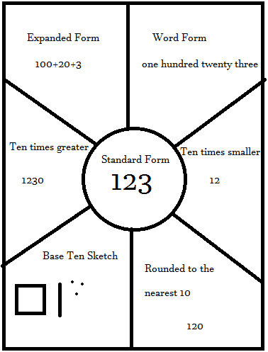Choose a number and complete Number Wheel | Spelling math  Choose ten focus words and find their sums.  a=1 b=2 c=3 d=4 e=5 f=6…etc…  CAT= 3 +1 +20 = 24  L.4.2, 4.NBT.B.4

